Pitch for an Independent Newspaper Op-Ed piece

Summary argument.

At a time when society is at last opening-up from Covid lock-down and where the Government is announcing multi-billion pound high-street and build back better programmes, are we in danger of forgetting to invest in the valuable ‘bottom-up’ change which local people largely do through their everyday work? In this 976 word op-ed piece, social entrepreneur and community leader argues that we don’t need more “Costa-fication” on the high street but community work-hubs and pubs which are run by groups of individuals from within neighbourhoods. If the Irish Government can do it, why can’t our Government invest in this grass-roots post-covid opportunity?

“Bottom-up” recovery <Draft title, could be a play on “bottoms up” toast! >

The scenes of people clamouring to get back onto the high street, pubs and shops this week as the Covid lockdown finally eases, brings to mind the phrase, most commonly attributed to Napoleon, that we on this side of the Channel are indeed a nation of shopkeepers.
It’s easy to see this phrase as derogatory, but I love the description. Shopkeepers are brave, they take risks, they love interacting with customers they help us connect not just with goods but with one another. Think of the best market stall holder or pub landlord you know and I bet you are already smiling!
If you dig deeper into the origins of this phrase you find that it was the Scottish Economist Adam Smith, who extended the debate when he wrote in the Wealth of Nations, "To found a great empire for the sole purpose of raising up a people of customers, may at first sight, appear a project fit only for a nation of shopkeepers. It is, however, a project altogether unfit for a nation of shopkeepers, but extremely fit for a nation whose government is influenced by shopkeepers." And so here is the rub, how can we measure whether our Government’s policy is truly influenced by the every-day shopkeepers, pub owners, youth workers, third-sector providers, faith- group leaders and the others who together keep the fabric of our communities strong? We know that Governments are influenced by the multi-national store-chain owners and financers, but as we build back better, we want more than the convenience and extension of “Costafication” on the high street, we need individual enterprises, boutique expressions of retail which are grown from the bottom-up by local people who love what they do in part because they keep the local character of an area intact and are the guardians of locally-lived values.
One Government which seems to be influenced by local shop keepers and pub owners is the Irish Government who this week announced that they would be investing in converting over 400 vacant buildings and support pubs to open up as workspaces to encourage more people to work remotely and support the wider eco-system of rural communities. Surely our politicians, so fond of being filmed having a drink at the local, could find a way of investing to keep our pubs and community hubs alive? They have announced their £3.6 billion ‘Towns Funds’ and proclaimed in their Build Back Better Plan how they will “embrace the instincts and know-how of the wealth creators, those in the private sector who invest money and take risks on new ideas that lead to new jobs and industry,” but how much of these funds will actually get down to the practitioners, the community health and wealth creators who are already doing the old jobs and old tasks of meeting the needs of local people?
Rishi Sunak’s promise in last month’s budget of help for communities to buy-back local assets is a start, but I suspect like most government initiatives it will be cumbersome, involve entrepreneurs taking on even more risk and uncertainty. Surely there must be a more flexible Dragons Den type programme for social entrepreneurs and those who are already serving their communities?
Yes, changes in building usage and mixed development in a high street may help increase the foot-fall, but pubs are instrumental in giving communities the foot-up. They are places where you recognise yourself in your neighbour, where you meet a stranger who often or not becomes an acquaintance and then a friend. This social currency isn’t exchanged overnight or built by a massive external government programme. No, these things take decades to ferment.
But it might be too late. I am already hearing the cries for “last oders” in my town where 3 local pubs have already closed during Covid. Many others are quite literally in the last chance saloon and you can almost hear the calls for last orders as the singer in the corner sings the still prophetic Joni Mitchel song, “Don't it always seem to go that you don't know what you got 'til it's gone.”
We need to act fast and recognise that investment in authentic ‘bottom-up’ regeneration has to be a crucial part of the re-opening programmes. Retail support yes, but also investment in the leaders of communities who are - in the phrase coined by Malcolm Gladwell, - the ‘Connectors.’ People who know people across an array of social, cultural, professional, and economic circles, and make a habit of introducing people who work or live in different silos and engineer serendipity and new projects. If Government’s fail to fund this soft-power in our communities we will see the emergence of the ‘K’ shaped recovery: Those who are self-sufficient and not reliant on the community will be on the upward projected graph, able to prosper from the new opportunities in a post-Covid world. For the young, poor and excluded who have already been disproportionately affected by Covid, the direction of travel is South.
Another way is possible, high streets are not just for shopping, we could make them amazing centres of civic, social and commercial connection. The ‘glue’ to bring diverse activities, people and projects together is having hubs which provide workspace, incubate ideas and training and nurture commercial and social entrepreneurialism.

Across the country we are seeing exciting models of community workhubs develop. Blending the best of our country’s hospitality and design culture with the injection of social innovation and outreach. Local connectors are creating inclusive, affordable, flexible community workhubs. With the ability to harness digital tools these can be tested and established quickly as a pop-up or prop-up for the high street before they and their surroundings become sustainable, agile and socially valuable spaces again. I believe that Community Work Hubs could be hatched in every high street, and if curated by hosts who value connectedness, enterprise and nurture opportunity, they could be instrumental in incubating new businesses and opportunities from the bottom-up.
END - 976 words
Stephen Carrick-Davies is a fellow of the School for Social Entrepreneurs. He currently runs the Hatcham House community work hub in South London and is helping other communities replicate the ‘Hatch Local’ model - See www.hatchamhouse.com
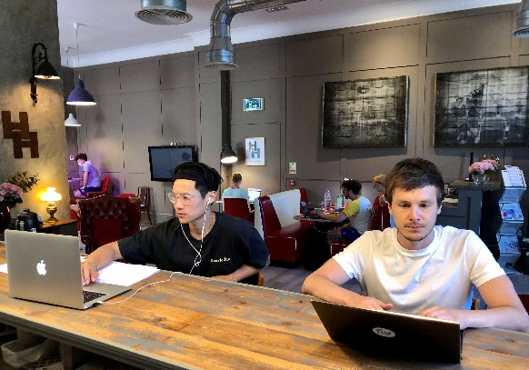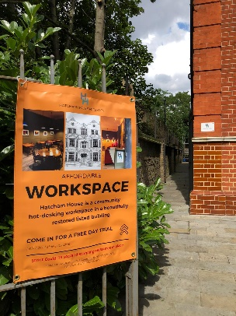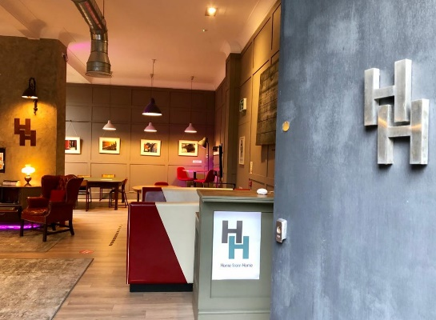
Photos and vox pops from some of the 150 members of Hatcham House available at www.hatchamhouse.com
See paper presented to Marvin Rees (Mayor of Bristol) at
www.hatchamhouse.com/replication.

